Abstract, #MS6-PS4, AsCA2015, Kolkata, India, Dec. 6 (2015)
Multiple two-dimensional X-ray detecting system on a powder diffraction beamline BL5S2 at AichiSR

Takashi Ida^{1,2}, Shoki Ono¹, Daiki Hattan¹, Kento Wachi¹, Shoji Tachiki², Yu-ki Nakanishi², Yasuhiro Sakuma², Hiroyuki Asakura^{2,3}, Masao Tabuchi^{2,3}, Nobuhisa Watanabe^{2,3}, Akiko Nozaki², Akio Wada² and Shin-ichi Towata²

¹Advanced Ceramics Research Center, Nagoya Institute of Technology, Asahigaoka, Tajimi, Gifu 507-0071,Japan.
²Aichi Synchrotron Radiation Center, Minamiyamaguchi-cho, Seto, Aichi 489-0965, Japan.
³Nagoya University Synchrotron Radiation Resarch Center, Nagoya University, Chikusa-ku, Nagoya 464-8601, Japan.

E-mail: ida.takashi@nitech.ac.jp
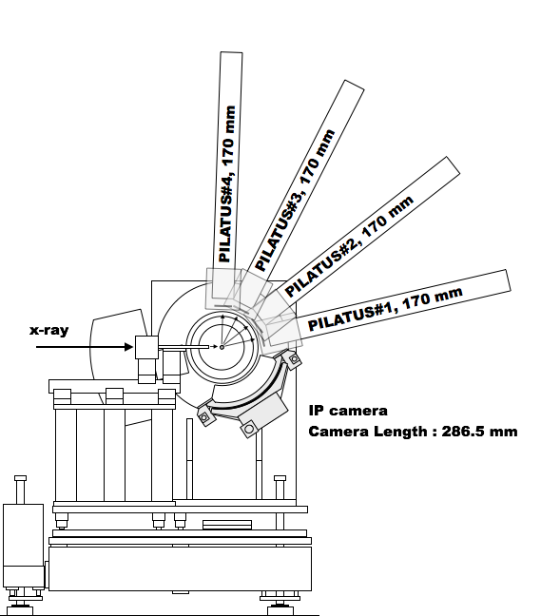
We have designed and constructed a new synchrotron powder diffraction measurement system on a beam-line BL5S2 at Aichi Synchrotron Radiation Center (AichiSR) in Seto, Japan. The synchrotron beam radiated from a superconducting bending magnet is supplied for the BL5S2 beam-line. The divergent radiation beam is paralleled with a cylindrical mirror, monochromated with double Si (111) crystals, and converged with another cylindrical mirror to the focal point, which is close to the face of the two-dimensional (2D) X-ray detectors, when they are located at the angle of 2θ = 0º. The 2Θ-flange of the goniometer (Huber, 401-440) mounts a cylindrical Debye-Scherrer camera with the radius of 265.4 mm, and four radially directed bars with the intervals of 25º for four 2D X-ray detectors (Dectris, PILATUS-100K). Each of the bars supports a linear guide with a movable stage that enables rapid operation to select any camera length from 340 mm to 1000 mm. The 2D detectors are eccentrically mounted to the rotation bearings attached to the movable stages, the axes of which are directed parallel to the supporting bars. The rotation system of the detectors is intended for two different purposes: (1) intentional inclination of the detectors that enables homogenous distribution of the diffraction angles assigned to the pixels, and (2) easy operation to switch the straightly aligned configuration to the front-back alternate configuration, which allows the minimum camera length of 170 mm and one-shot non-missing diffraction measurement covering the range of the diffraction angles 2θ : 1.5º ~ 101º, where the lowest angle is restricted by the shadow of the head piece of the direct beam stopper. Figure 1 schematically illustrates the one-shot configuration of the detecting system. It has been found that the intentional inclination of the 2D detector is effective to avoid the unfavorable effects caused by anomaly of the intensities counted with the pixels located close to the boundaries of the monolithic components of the composite X-ray detectors. The 2D intensity data are treated by a modified method of Sulyanov et al. [1], to obtain one-dimensional powder diffraction intensity data, which enables us to obtain aberration-free peak profile and also experimental estimation of the statistical variance or standard deviations of the observed intensities.
FFig. 1 Schematic illustration of the powder diffraction measurement system on BL5S2, AichiSR.

References
- Sulyanov S. N., Popov A. N. and Kheiker D. M., “Using a two-dimensional detector for X-ray powder diffractometry”, J. Appl. Cryst., , Vol. 27, (1994), 934-942.

